**Executive Summary**

* CamBoard* is the sustainable solution to a fire-safe home.
* Reduced embodied carbon (sustainability) (40% reduction in CO2)
* Needs of the construction sector:
  + Cost efficient boards
  + Energy intensive (low intensity) manufacturing (low temperature/pressure firing process)
  + Routes to sustainable material sourcing & recycling for the industry (SAAPI & PMS)
* Business model: B2B addresses clients
* End use for the product should mainly adhere to residential use (comply with the standards used in constructing residential buildings - public and private).
* Primary research confirms that Cambond should target the manufacture of class B flame resistant board.

**Introduction to CamBoard\***

* Flat construction panels (no complex shapes ie moulded were considered).
* Beveled edged and flat edged panels were incorporated in the analysis (pricing competitor products).

Sustainable Cities and Communities, Responsible Consumption & Production and Climate Action are named as three of the main goals towards achieving “A better and more sustainable future for all by 2030” by the United Nations [1]. CamBoard is a solution offering a significant step towards reaching these goals, without compromising on the demands of modern lifestyle.

Plasterboards can be used for a variety of purposes, ranging from

**Plasterboard (also drywall,** [**gypsum board**](https://www.reportsanddata.com/report-detail/global-gypsum-board-market-by-manufacturers-regions-type-and-application-forecast-to-2022)**, gypsum panel) is a popular building product used to construct ceilings and interior walls. The booming construction and infrastructure industry is driving the growth of the plasterboard market. A rise in the level of disposable incomes and rapid growth in population across the globe will fuel the market growth.**

the rising investments in smart cities in the emerging economies will also boost the demand for plasterboard worldwide.

The development of eco-friendly and sustainable construction methods will impact the demand for plasterboards in the coming years.





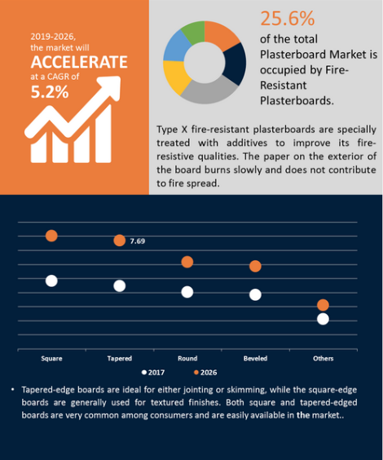

* The defining attribute of Camboards will be flame resistance (main selling point)
* 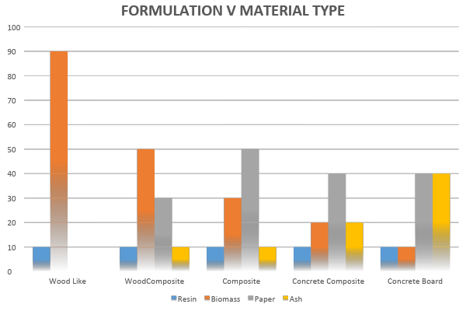.
* Our analysis leads to a preference for class B plasterboards in the market. We this recommend Cambond to focus on flame retardant boards with the following composition: (Ash: 20-40%, ….)

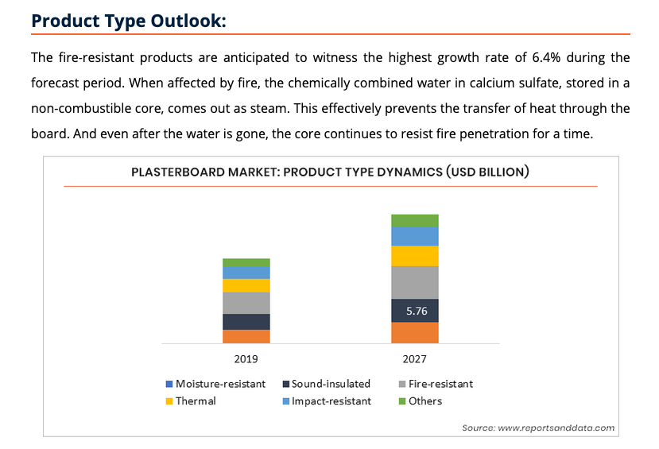

Sustainable Cities and Communities, Responsible Consumption & Production and Climate Action are named as three of the main goals towards achieving “A better and more sustainable future for all by 2030” by the United Nations [1]. CamBoard is a solution offering a significant step towards reaching these goals, without compromising on the demands of modern lifestyle.

CamBoard aims to shake up the way we currently approach construction - industry whose carbon footprint makes up 45 % of UK’s carbon emissions and embedded carbon [2]. The technology reuses materials salvaged from paper recycling and … processes that would otherwise be disposed of in landfill. The main materials - fly ash, paper mill sludge and distillers dried grains and solubles - are non toxic and the mild conditions of the production process as well as the waste streams used to source these materials mean that the overall process has low (source?) carbon footprint.

Today’s industries’ standards require a certain degree of safety from manufacturers [some source], with particular emphasis on fire resistance. …. Camboard fills a (needed?) gap where it is possible to have a low cost eco-friendly and high standards construction panel with fire resistance properties….

The key to CamBoard’s fire resistance is use of of high mineral content fly ash and paper sludge to produce panels suitable as a replacement for

… introduction to CamBoard’s properties we don’t have much information on yet and a little discussion with regards it being used as a fireproof thing. …

A clear and certain shift of society’s attention towards long-term implications of everyday choices, strong regulatory incentives towards greener solutions [] and pressing need for sustainable living provide a clear opening for a product promoting circular economy []. Moreover, abundance of fly ash and paper mill waste, low production cost and uncomplicated (?) manufacturing process of CamBoard suggest a potential in uptaking this technology.

Picture: something like circular economy from Gareth’s presentation?

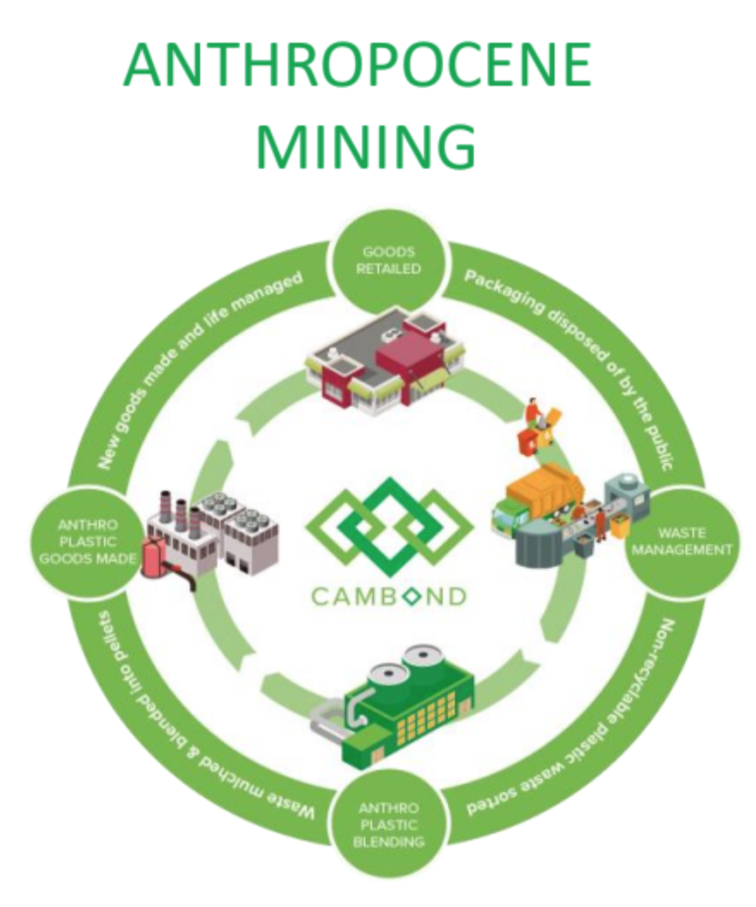

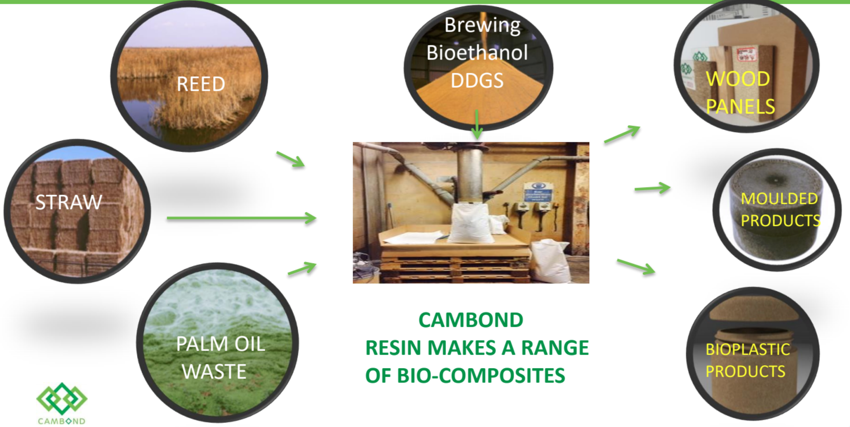

* Place holder name and pictures

[1] citation needed: part of their mission statement

[2] <https://www.designingbuildings.co.uk/wiki/Sustainability_in_building_design_and_construction>

---

<https://www.gov.uk/government/publications/department-for-communities-and-local-government-single-departmental-plan/ministry-of-housing-communities-and-local-government-single-departmental-plan--2> - govt (under no 5) wants to ensure that people are safe and feel safe within their homes (with respect to fire)

Cambond has worked with Saapi to see if MLS could be used in higher value construction products. Manufacturing construction products from paper mill waste, ash and resin enables them to be embedded into buildings for up-to 100years. This dramatically reduces the embodied energy and carbon footprint of paper mill and combustion industries.

.

**Gaps between current position and minimum viable product**

Section should cover:

* Discussion of the production process
* Testing
  + Composition
  + Ignitability test
  + EN13950
  + Class 0 Building Regulations classification

| **Board Component** | **Composition wt %** |
| --- | --- |
| Bioresin | 15 |
| Fly Ash | 20-40 |
| Paper sludge | 65-45 |

* + Manufacturing process (consistency and scalability) - Low temperature firing.
  + To comply with regulatory requirements
    - Make a list with bodies (BBA,

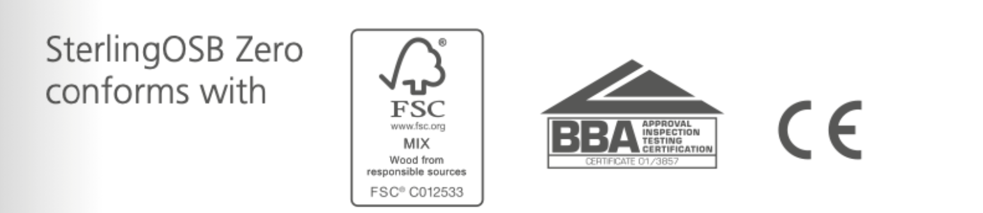

* Minimum viable product: flame-resistant flatboard (or the process to manufacture flame-resistant flatboards)

Picture: summary of process from waste to board to its use in construction or overview of the process of making the Cambond’s boards (no information on process →

| **Results from using biocomposite resin on wood based and/or straw board material:** |
| --- |
| 1. The bio-based urea-formaldehyde composite material for wood-based panels provided by the invention can greatly reduce the release amount of formaldehyde in the artificial board. |
| 2. It can enhance the bonding performance of the urea-formaldehyde glue to the wood material or the crop straw. Also good moisture resistance |
| 3. It not only meets the environmental protection requirements but also expands the raw materials. Source, with obvious effects |

<https://hanson-plywood.co.uk/products/fire-retardant-mdf/>

* BS EN also for Gypsum boards.

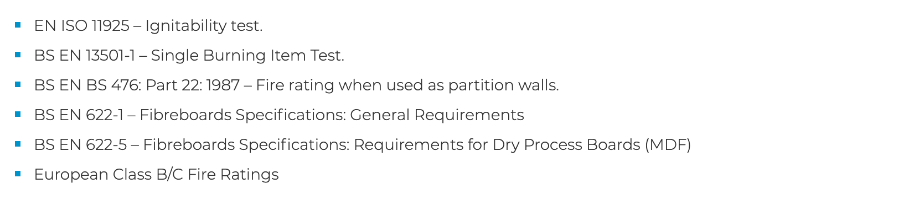

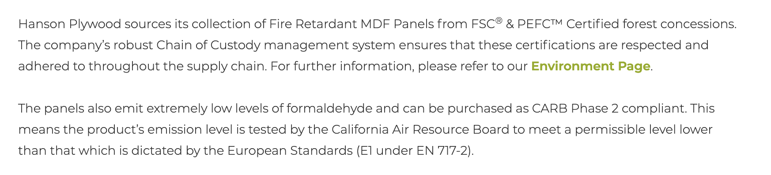

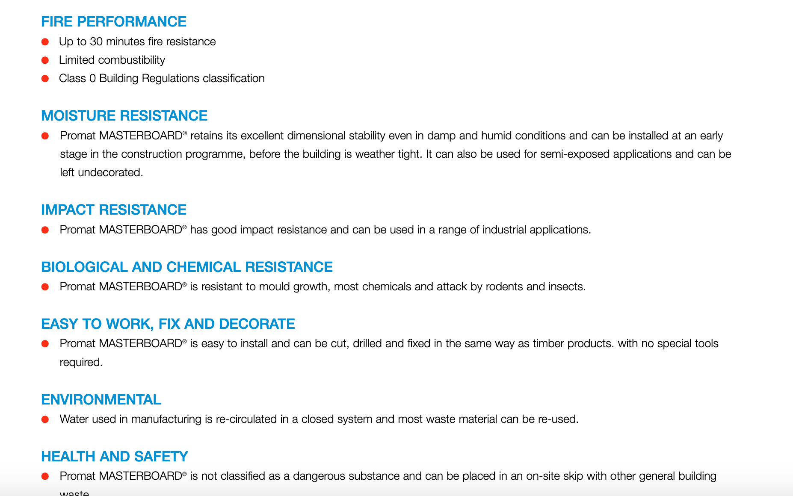

**Application, industry and market place**

Source: IBISWorld

**Fire resistant boards in the UK: Regulations and Market Trends**

The standard measures applicable in this industry are reaction to fire (governed by EN13501-1) and fire resistance (governed by EN13501-2).

EN 13501-1 segregates materials into classes A-F, with the classes A1-A2 comprising non-combustible materials whilst remaining classes comprising materials with a variable reaction to fire, starting from materials with a very limited reaction to fire (Class B) to those which are flammable (Class F). Concurrently, EN 13501-2 looks at the load bearing capacity, fire penetration (integrity) and transfer of excessive heat (insulation) in terms of minutes. Materials are also designated with a smoke classification and a flaming droplet classification upon testing.

We will focus mainly on Class A and B boards for the purpose of this report.

Class A Boards

These include gypsum and cement-based boards, whose market analysis is presented below. By law, most high-rise buildings require Class A boards only.

Gypsum-based boards are manufactured as part of the lime and plaster industry and incurred an annual revenue of £193.3 M in 2020-21 with an anticipated growth of 3.7% in 2021-26. The sector experienced a negative 2.5% growth in 2020-21, due to the impact of Covid-19. This sector has an average profit margin of 2.7% and is dominated by a few major players, namely Saint-Gobain Construction Products UK Ltd (13.7%), Lhoist UK Ltd (13.5%), Singleton Birch Ltd (12.4%), Tarmac Cement and Lime Ltd (5.6%). Market analysis has shown this to be growing in comparison to the building plaster sector, although there is low technology change. The residential market was seen to drive most of the demand in this sector.

Cement-based boards, which are part of the building plaster product sector account for an annual revenue of £831.7M annual revenue with a projected growth of 6.8% in 2021-26. The sector was similarly impacted due to Covid-19 and experienced a negative growth of 1%. The average profit margin is considerably higher at 17%, although the market is perceived as mature and harder to enter. Similar to the lime and plaster industry, there is low technology change. The sector is again dominated by a few players, namely Saint-Gobain (56.9%), Etex (19.1%) and Knauf (14.1%). The residential market is perceived to be lucrative to pursue for short to medium-term opportunities.

Class B Boards

These include wood-based materials such as medium-density fibreboard (MDF), particle board and oriented strand board (OSB). Most of these materials acquire fire-resistance through the addition of a flame-retardant chemical. The class B boards are also used as non-load bearing materials.

These boards are manufactured as part of the wood panel industry in the UK, which has an annual revenue of £1.2 billion and a projected growth rate of 1.3% in 2021-26 with Covid-19 resulting in a negative 1.1% growth. With regard to revenue generation, this sector is heavily dependent on residential construction. The sector operates on similar profit margins to the lime and plaster industry, with an average of 2.3%. Similar to the Class A market, the sector is mature and dominated by a few players, namely Norbord (25.3%), Egger (23.7%) and Kronospan (17.4%). However, it is slightly less concentrated in comparison to the lime and building plaster industries with a larger number of small and medium businesses in operation. There is an encouraging trend of premium pricing for higher quality products and the requirement to comply with environmental regulations, both of which might work to Cambond’s advantage.

**Drivers in the UK Construction Industry: Trends and Policy Landscape**

Add how items are procured

Policy - Help to Buy, Grenfell, sustainability - BREEAM certification etc.

**Trends in construction sector activity: current and future projections**

Source:statista & IBIS world

Construction activity was flat in 2020 during the covid-19 pandemic. The market for new residential buildings was the most resilient part of the UK market. Activity related to private housing in particular, drove the largest falls and recovery in the construction sector over the pandemic period. In the 3rd quarter of 2020, new private housing construction revenue output suffered the least % change (-1.5%). In addition, public residential housing reached pre-pandemic levels in construction activity during the 3rd quarter of 2020.

As far as new residential housing construction starts are concerned, an overall increase of 137.5 % is expected between 2020 and 2024. Regarding private residential housing, a rate of increase in revenue of 3% is expected between 2020 and 2024. The same does not hold true for public residential housing, for which the rate of increase in revenue is expected to decline from 6 to 2% between 2020 and 2022 respectively and plateau at 2% for the years up to 2024.

Overall, revenue in the construction of buildings is forecast to increase by 32% between the years 2021 and 2024.

The residential construction sector appears to be the best performing sector. End use applications for class B fire resistant boards are well suited for this sector as these include internal wall coverings, ceilings, wall cladding and flooring applications. Regulations and new policies around the issue of reduced embodied and operational carbon for buildings in the UK, signify that there is potentially space for new and sustainable building materials in this sector.

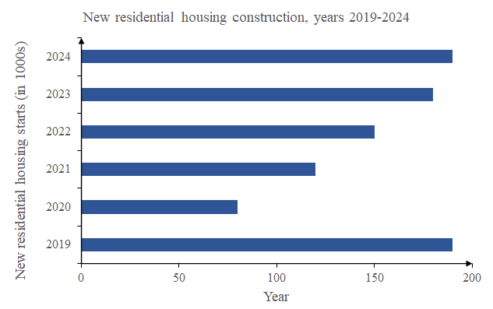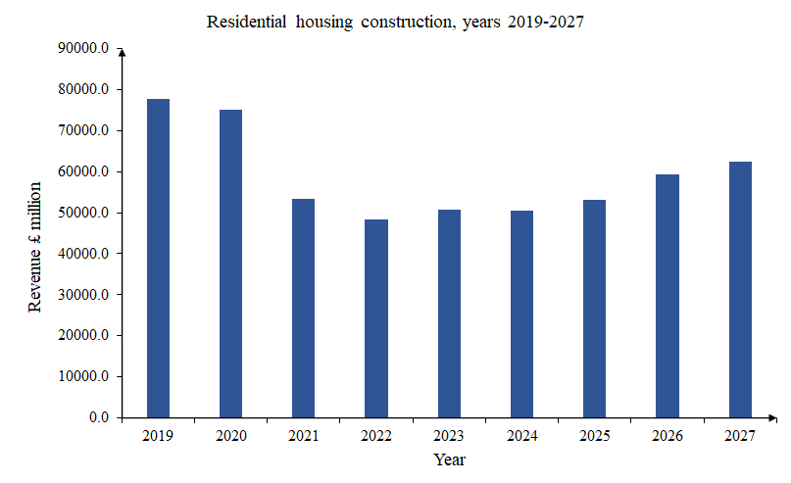

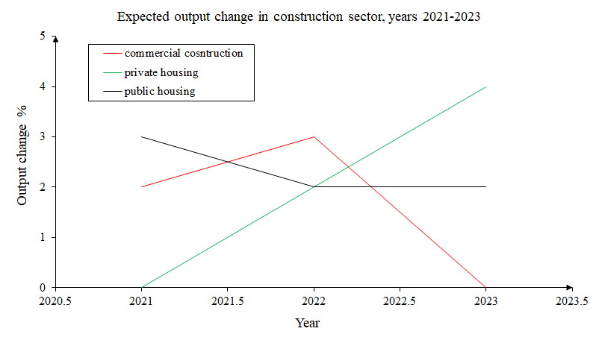

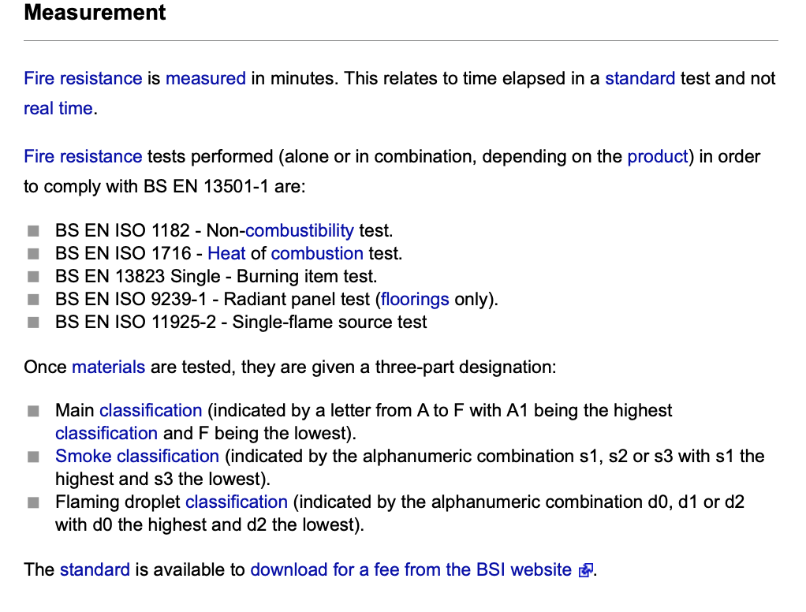

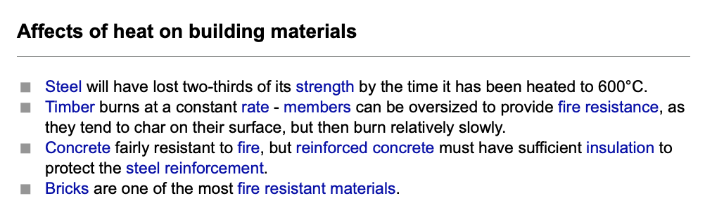

**Competitor landscape**

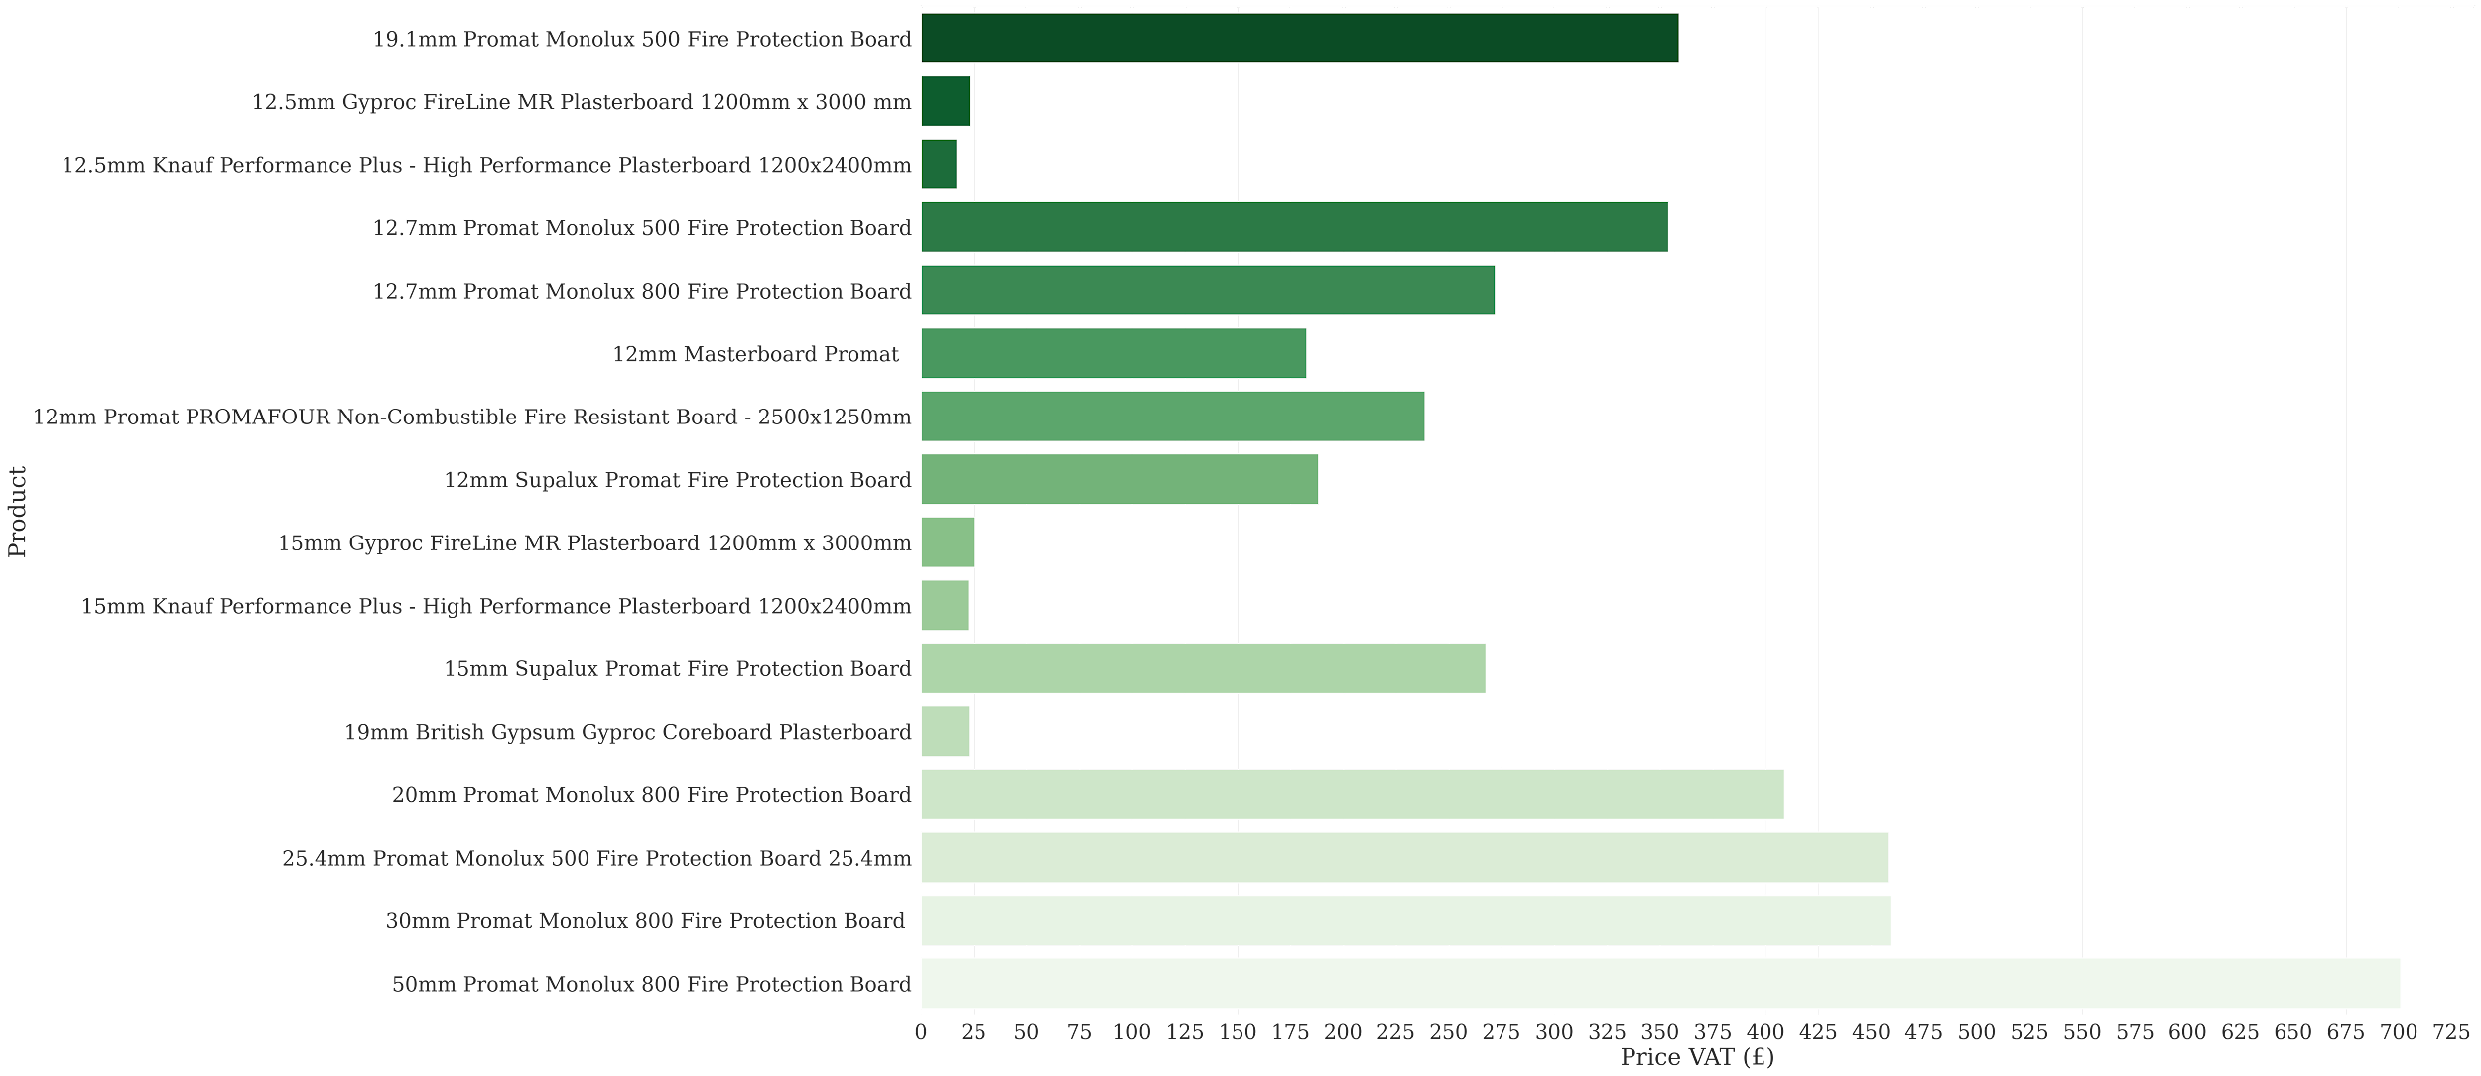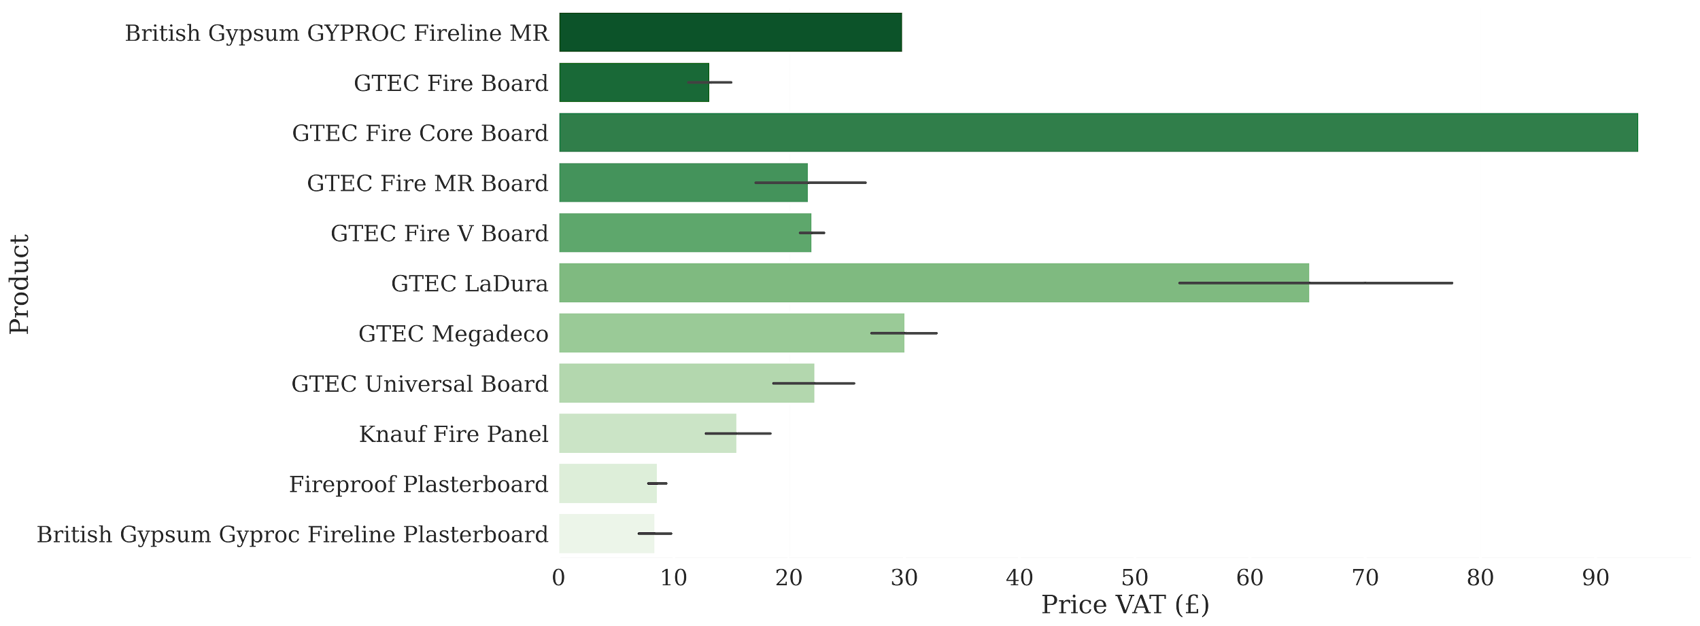

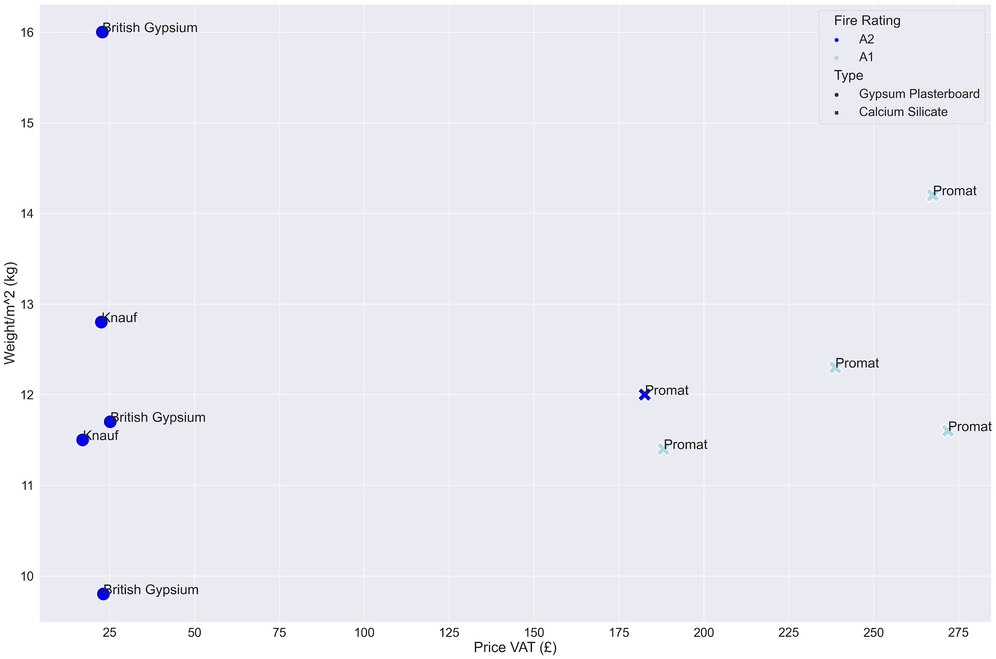

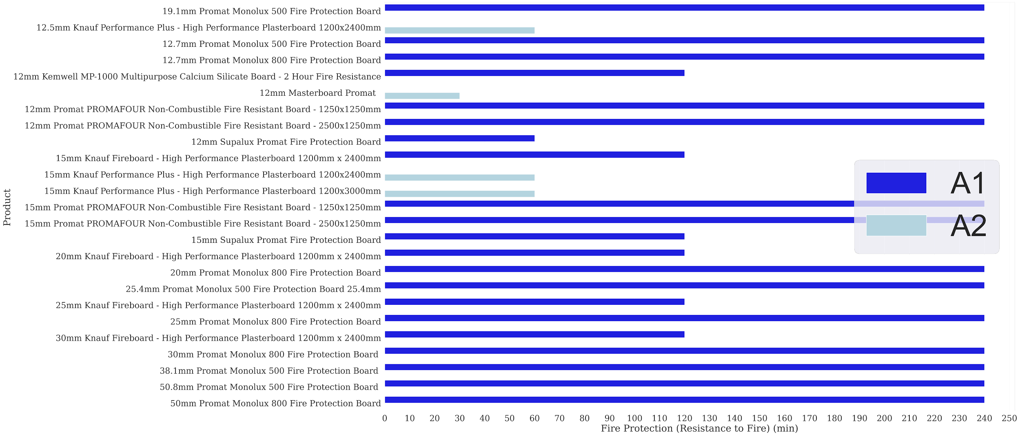

**MISSING STUFF:**

* **Mineral Wool**
* **Processed Wood**
* **Fiber Cement**
* Key market players offering cement based and plaster boards. Also, other substitutes exist such as enviroboards. These must also be accounted for
  + I think we definitely need to discuss process wood or other non-cement/plaster boards. These are a bit lower fire resistance standard, but without knowing Cambond’s test results I suspect that Cambond’s product wouldn’t reach A1/A2 category (which is entirely non-combustible materials) and so might be competing with these. - Elena

Here <https://github.com/Saladino93/EnterpriseTech/blob/master/ScrapedPrices.ipynb> , Omar

Table X: Typical characteristics of competing products vs CamBoard

| Board type | Examples | Density (kg/m3) | Fire resistance (REI, min) | Fire reaction category | Typical cost  (£/m^2 or sth?) | Working notes |
| --- | --- | --- | --- | --- | --- | --- |
| Gypsum plasterboard | British Gypsum | 700 +- 100 | 60 | B-A1 |  | Defined in BS EN 520 |
| Calcium Silicate | Supalux Promat | 870 +- 50 | 240 | A1 |  | Defined in BS EN 14306. Contains **fly ash** and silica sand in place of most of the cement that goes into fibre cement boards |
| fibre-cement |  | 1800 +- 200 | 120 | A1 (what they are mainly sold as) |  |  |
| Processed wood | Ptg treatments/ sentinir | 600-900 (oak) |  | B & C |  |  |
| Mineral wool | Rockwool (made of basalt volcanic stone), Knauf (Fire-Tek beams) | 40-100 nominal & 30-250 relative. Rockwool sells high performing one of 160-180 | 60-120-240 scales with price | European class A1 (Knauf) | 24-52.12 £/m + incurred delivery and load costs (depending on size of load order). At full load zero such cost. Price is per unit length | 0.034-0.067 W/(mK) at 50 & 250 C respectively. See EN 13501-1 / UL 723 for fire performance standards. Mostly applied in internal partitions due to excellent acoustic performance |
| Plywood birch panels | Treated with phenol formaldehyde (toxic) | 600 +- 100 |  | Euro class B (structural applications) |  |  |
| Particle boards |  | 650 and 750 kg/m³ |  | Class B covered but also class A1-A2 |  |  |
| MDF | Norbord | 800 +- 200 | 30-60 min | Class B & C |  |  |

Flame retardant board manufacturers (established players):

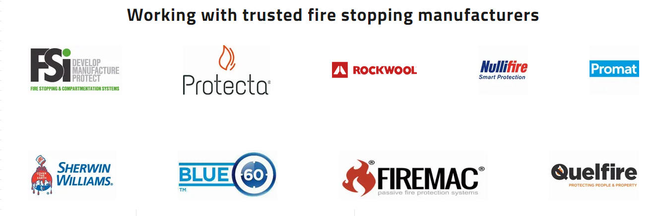

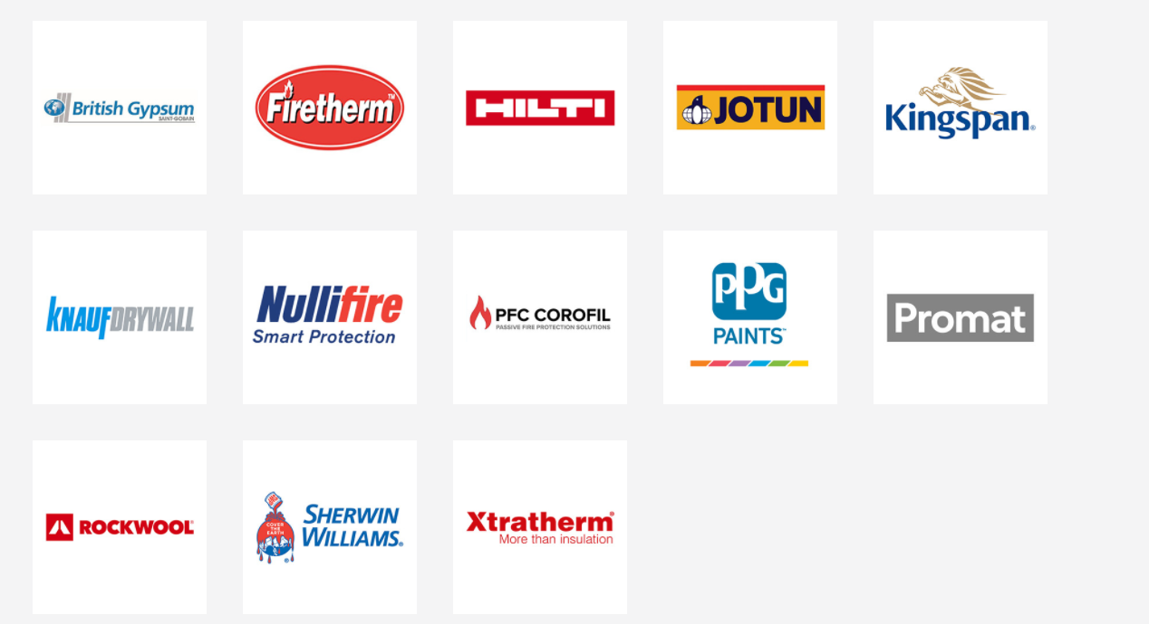

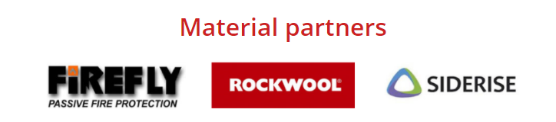

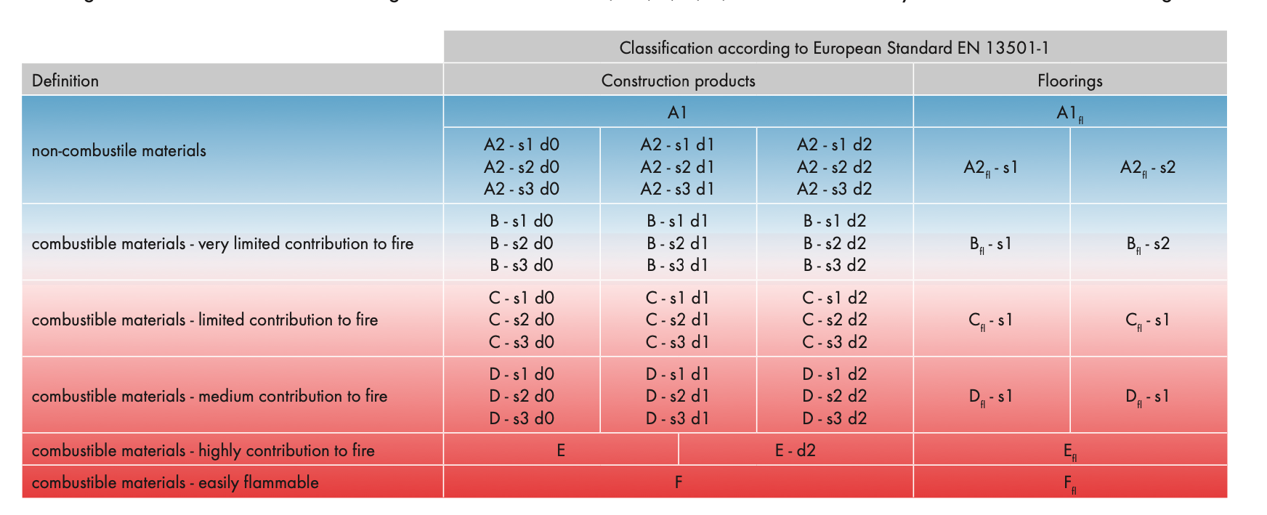

Innovative emerging players:

**Enviroboards** (<https://www.fireboards.co.uk/fire-board---uk-accredited-tests>

+ 6mm boards

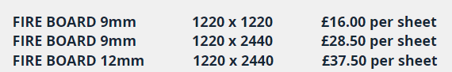

(prices exclude 20 % standard rate VAT)

**Resistant buildings ltd** (magnesium oxide boards). They are expensive

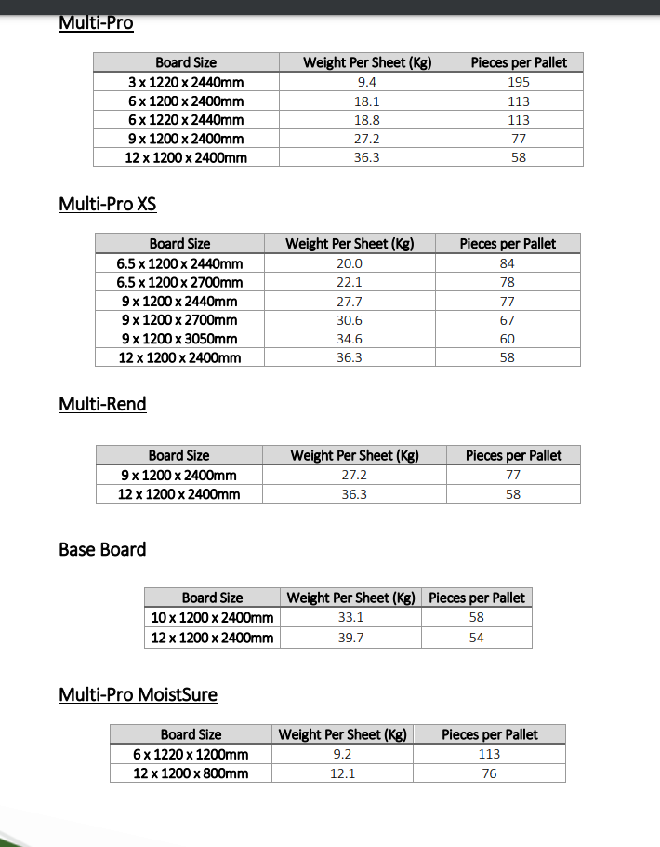

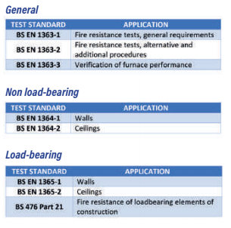

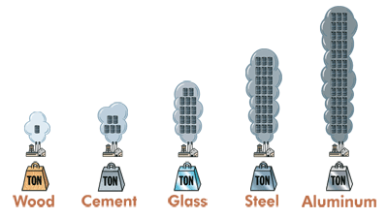

https://www.performancepanels.com/sustainability

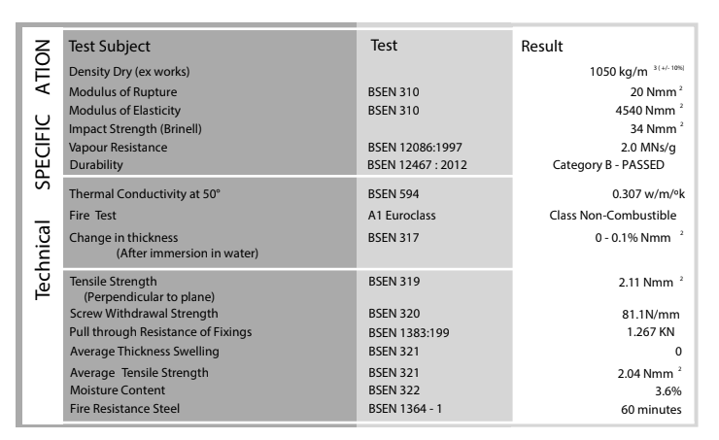

**Example to beat**

**Enviroboards, Resistant Buildings [manufacturers innovation]-Nothing about flame retardant coatings**

Looking over the marketplace this company looks like an interesting competitor.

New technology aimed at replacing plywoods and OSB.

https://www.resistant.co.uk/products/base-board/

Look at website I have attached technology detail. Are there other companies like this?

How does their product portfolio range over price and applications?

Are there other companies with innovative products like this? [NB: Resistant Multi-pro]

**SWOT Analysis**

| **Strengths**   * Cheap (no data on this?) & flexible (many paper mills, etc) feedstocks * Sustainable product (is it insulating too?) * Quite light, compared to others, a plus for transportation | **Weaknesses**   * **Shear/compression strength?** * As a startup, they might not be able to control the whole supply chain -> construction material manufacture is resource and capital intensive |
| --- | --- |
| **Opportunities**   * Governments starting to think about sustainability - regulations could follow in the future * Society (end users) are increasingly choosing sustainable & environmentally friendly products | **Threats**   * Large companies such as Saint-Gobain already have similar products * Norbord * Resistance to change in the market/industry * Tricky IP rights * Low margins (no/low premiums) |

**Potential early adopters**

* Experimental architecture
* Businesses in the construction sector that prioritise sustainability given a reasonable cost margin and profits could adopt the product offered by Cambond. Look into regional, segmented manufacturing businesses as opposed to national ones, or identify national players (vendors, distributors and/or manufacturers with potential pain points that Cambond can leverage to promote their product.

**Commercial advantages**

* Compare to products already in the market via their specs - we need information on costs

This? Here <https://github.com/Saladino93/EnterpriseTech/blob/master/ScrapedPrices.ipynb> , Omar

* Flexibility in feedstock - less dependence on suppliers, etc (access to fly ash?)
* Access to manufacturing partners - potentially lower costs and infrastructure

**Primary market research**

**Insights from industry experts**

We consulted around 7 key decision makers in the UK construction industry, namely architects, quantity surveyors, representatives of builders’ merchants, sustainability officers and design coordinators.

Pricing

The general consensus was that the potential product would need to compete on price while meeting the relevant fire rating certifications, at a minimum. The Class A and Class B markets cater to different types of projects and associated capital value, therefore this is key for Cambond to consider. Our literature search was validated by expert opinions in that the Class B boards are more suited to residential buildings.

Class B fire resistant boards are either treated plywood or MDF boards and sold at an average pre-VAT price of £45. The relevant average price considers 12 mm thickness boards, similar to the dimensions that Cambond can manufacture. Builders merchants such as Huws Gray (Ridgeons) typically offer discounts up to 20% for bulk purchases. Assuming this discount rate applies, post discounted boards amount to an approximate average value of £36. Builders’ merchants and indeed any distributors and suppliers in most industries wouldn’t accept offers for products from manufacturers, unless they stand to make a minimum profit of 25%. By assuming the extreme scenario of 50% profit, that leaves Cambond with a price per board of approximately £18. Their cost of production is £3.5 per unit. Company overheads, IP costs, marketing costs etc are not included. These costs are highly unlikely to raise the total cost for a given Camboard above £18.

Desirable characteristics

When probed about desirable characteristics of products, industry players highlighted that fire-resistant boards are generally used in non-load bearing applications, therefore it is preferred that they are as light as possible. Heat-related insulation properties were not as important, but some alluded that acoustic insulation would be beneficial if the board is to be used in internal settings. Other key aspects mentioned were safety and durability - a few respondents also specifically mentioned the Grenfell tragedy.

With regard to capitalising on the sustainability aspect of Cambond, this was received very positively by nearly all decision makers. The BREAAM certification was referred to as a must-have, coupled with end-to-end assessment of the product lifecycle - this refers to the route from manufacture to disposal. Sustainability is also seen as a key driver in the construction industry due to recent regulations such as ….

Route to market for Cambond

Routes to market for a new player in the construction industry are slightly challenging, in view of long-standing existing contracts with large players such as British Gypsum (a subsidiary of Saint Gobain). However, respondents pointed out that innovative materials are often pitched by architects who are more concerned about sustainability. However, their recommendations might be vetoed by quantity surveyors and design coordinators who are most cost-conscious, unless sustainability is a key requirement of the client. Most key decision makers preferred a direct relationship with suppliers, however some procured their materials through builders’ merchants.

**Insights from end-users**

We surveyed over 170 potential end-users of building materials in the UK. The key questions tried to elucidate various factors from awareness to perception. We have presented our findings by section below.

Demographics

Our survey respondents were from the following age-groups: 18-25 years (45.8%), 26-35 years (19.4%), 36-45 years (16.4%), 46-55 years (10.5%) and >55 years (8.2%). The percentage of homeowners vs non-homeowners was 46.5% against 53.5%. Respondents were mostly from England, and homogeneously distributed across the various counties.

General awareness of flame-resistant boards and perception of existing products

While 68.8% of respondents agreed that the building materials used in their homes were important to them, only 41.1% were aware of the flame-resistant flatboard offerings available to them. 54.7% were not aware of the chemicals used to impart flame-resistant properties to flatboards.

Subsequently, respondents were informed about the presence of harmful chemicals in existing products to promote flame-resistance. Although only 24% of respondents were aware of these chemicals, 79.4% said that they were highly concerned about this.

Attractiveness of Cambond’s offering and desirable features of proposed flatboard

Respondents were also exposed to proposed characteristics of Cambond’s board using keywords such as ‘environmentally friendly’ and ‘inorganic materials such as fly ash to impart flame-retardant properties’. To this, 58.8% responded positively while 28.8% indicated a possible interest.

The top 3 features attractive to the respondents were: 1) Safety, 2) Durability and 3) Cost-effectiveness, in that order.

Respondents were also asked the willingness to pay a premium for Cambond’s product given its environmentally-friendly properties. 40.5% were willing to go over 10% of the average market price for a comparable product, while 25% were willing to pay up to a premium of 25%. 15% of respondents said that they would not prefer to pay beyond the average price for Cambond’s product.

**Intellectual property position**

* SAAPI lignosulfonate and cambond bioresin [BCB technology]. - existing patents - manufacturing boards -> is there a more specific patent for this product? (mention magnesium oxide boards and magnesium oxychloride treatment) - boards and flame retardant solution treatments
* Information on other competing patents - Chinese and Taiwanese companies

**Potential business models**

* Business model canvas
  + Licensing
  + End-to-end control of supply chain

**Commercial potential of technology**

* Can we sell the product at a premium price?
* Is there potential for exponential growth? (can there be wide-scale adoption?)
* Potential of Cambond technology in general:
  + Variety of products
  + Valorise waste materials

**Concluding remarks and recommendations**



**Footnotes:**